***Group Facilitator:*** *RAJESH SUGURU*

***Team:*** *RAJESH SUGURU and VIGNESHWAR RAMAYI*

***Ref:***[*https://learn.upgrad.com/v/course/498/module/31215*](https://learn.upgrad.com/v/course/498/module/31215)

***Assignment:*** *C5: Neural Networks Project - Gesture Recognition*

# Problem Statement

Ref: <https://learn.upgrad.com/v/course/498/session/89243/segment/499656>

*As a data scientist at a home electronics company which manufactures state of the art smart televisions. We want to develop a cool feature in the smart-TV that can recognise five different gestures performed by the user which will help users control the TV without using a remote.*

* Thumbs up :  Increase the volume.
* Thumbs down : Decrease the volume.
* Left swipe : 'Jump' backwards 10 seconds.
* Right swipe : 'Jump' forward 10 seconds.
* Stop : Pause the movie.

**Data Location:** [**https://upgrad.nimblebox.ai/dashboard**](https://upgrad.nimblebox.ai/dashboard)

**Upgrad Google Drive:** <https://drive.google.com/uc?id=1ehyrYBQ5rbQQe6yL4XbLWe3FMvuVUGiL>

# Understanding the Dataset

Ref: <https://learn.upgrad.com/v/course/498/session/89243/segment/499656>

*The training data consists of a few hundred videos categorized into one of the five classes. Each video (typically 2-3 seconds long) is divided into a sequence of 30 frames (images). These videos have been recorded by various people performing one of the five gestures in front of a webcam - similar to what the smart TV will use.*

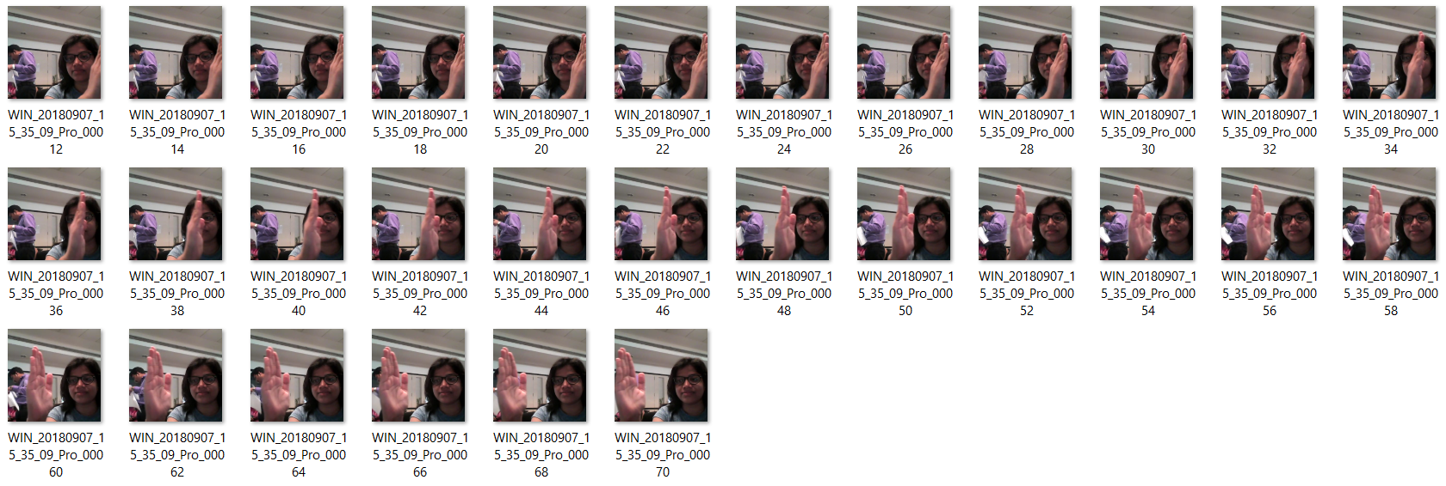

# Objective

*Our task is to train different models on the 'train' folder to predict the action performed in each sequence or video and which performs well on the 'val' folder as well. The final test folder for evaluation is withheld - final model's performance will be tested on the 'test' set.*

# Two types of architectures suggested for analysing videos using deep learning:

1. **3D Convolutional Neural Networks (Conv3D)**

*3D convolutions are a natural extension to the 2D convolutions. Just like in 2D conv, we move the filter in two directions (x and y), in 3D conv, we move the filter in three directions (x, y and z). In this specific case, the input to a 3D conv is a video (which is a sequence of 30 RGB images). If we assume that the shape of each image is 100x100x3, for example, the video becomes a 4D tensor of shape 100x100x3x30 which can be written as (100x100x30)x3 where 3 is the number of channels. Hence, deriving the analogy from 2D convolutions where a 2D kernel/filter (a square filter) is represented as (fxf)xc where f is filter size and c is the number of channels, a 3D kernel/filter (a 'cubic' filter) is represented as (fxfxf)xc (here c = 3 since the input images have three channels). This cubic filter will now '3D-convolve' on each of the three channels of the (100x100x30) tensor*

.

**30 frames….**

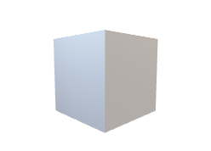**Depth**

**Error**

**Conv3D**

**Back**

**Propagation**

**RGB**

***e****.g****.****(100x100x3x30)*

**Update**

**Figure 1: A simple representation of working of a 3D-CNN**

1. **CNN + RNN architecture**

*The conv2D network will extract a feature vector for each image, and a sequence of these feature vectors is then fed to an RNN-based network. The output of the RNN is a regular softmax (for a classification problem such as this one).*

**Figure 2: A simple representation of an ensemble CNN+LSTM Architecture**

# Data Generator

*The generator should be able to take a batch of videos as input without any error. Steps like cropping, resizing and normalization should be performed successfully.*

*This is one of the most important parts of the code. In the generator, we are going to pre-process the images as we have images of 2 different dimensions (360 x 360 and 120 x 160) as well as create a batch of video frames.*

# Data Pre-processing

* ***Resizing and cropping of the images.*** *This was mainly done to ensure that the NN only recognizes the gestures effectively rather than focusing on the other background noise present in the image.*
* ***Normalization of the images.*** *Normalizing the RGB values of an image can at times be a simple and effective way to get rid of distortions caused by lights and shadows in an image.*
* *At the later stages for improving the model’s accuracy, we have also made use of data augmentation, where we have slightly rotated the pre-processed images of the gestures in order to bring in more data for the model to train on and to make it more generalizable in nature as sometimes the positioning of the hand won’t necessarily be within the camera frame always.*

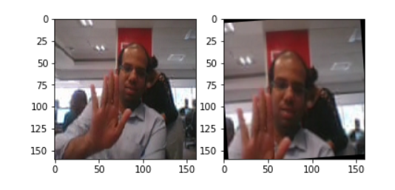

**Note:** It was taken into consideration that we don’t rotate images to a greater extent as this would change the meaning of the gestures completely

# NN Architecture development and training

* *Experimented with different model configurations and hyper-parameters and various iterations and combinations of batch sizes, image dimensions, filter sizes, padding and stride length were experimented with. We also played around with different learning rates and ReduceLROnPlateau was used to decrease the learning rate if the monitored metrics (val_loss) remains unchanged in between epochs.*
* *We experimented with SGD() and Adam() optimizersbutwent forward with Adam() as it lead to improvement in model’s accuracy by rectifying high variance in the model’s parameters. We were unsupportive of experimenting with Adagrad() and Adadelta() due to the limited computational capacity as these take a lot of time to converge because of their dynamic learning rate functionalities.*
* *We also made use of Batch Normalization, pooling and dropoutlayers when our model started to overfit, this could be easily witnessed when our model started giving poor validation accuracy inspite of having good training accuracy.*
* *Early stoppingwas usedto put a halt at the training process when the val_loss would start to saturate / model’s performance would stop improving.*

# Observations

* *It was observed that as the Number of trainable parameters increase, the model takes much more time for training.*
* *Batch size ∝ GPU memory/ available compute.A large batch size can throw GPU Out of memory error,and thus here we had to play around with the batch size till we were able to arrive at an optimal value of the batch size which our GPU could support ( NVIDIA Tesla K80 GPU with 12GB memory provided by nimblebox.ai platform.)*
* *Increasing the batch size greatly reduces the training time but this also has a negative impact on the model accuracy. This made us realise that there is always a trade-off here on basis of priority -> If we want our model to be ready in a shorter time span, choose larger batch size else you should choose lower batch size if you want your model to be more accurate.*
* *Data Augmentation and Early stopping greatly helped in overcoming the problem of overfitting which our initial version of model was facing.*
* *CNN+LSTM based model with GRU cells had better performance than Conv3D.As per our understanding, this is something which depends on the kind of data we used, the architecture we developed and the hyper-parameters we chose.*
* *Transfer learning* ***boosted*** *the overall accuracy of the model. We made use of the* [*MobileNet*](https://arxiv.org/abs/1704.04861) *Architecture due to it’s light weight design and high speed performance coupled with low maintenance as compared to other well-known architectures like VGG16, AlexNet, GoogleNet etc.*
* *For detailed information on the Observations and Inference, please refer Table 1.*

|  |  |  |  |  |
| --- | --- | --- | --- | --- |
| Experiment Number | Model | Result | Decision + Explanation | Parameters |
| 0 | **Conv3D** | **OOM Error (Out Of Memory)** | **Reduce the batch size and reduce number of neurons in highly dense layer** | **-** |
| 1 | **Training Accuracy : 0.99**  **Validation Accuracy:0.66** | **Model Over fitting**  **Value loss does not improve from 0.65.**  **Add some dropouts** | **1,117,061** |
| 2 | **Training Accuracy: 0.90**  **Validation Accuracy: 0.85** | **More number of parameters (3.6 Million). When tried to run multiple times model stopped early. Let’s lower the learning rate and number of parameters.** | **3,638,981** |
| 3 | **Training Accuracy: 0.83**  **Validation Accuracy: 0.81** | **Great Accuracy with the reduced parameters by half compared to Model 2 .Let’ try adding more layers.** | **1,762,613** |
| 4 | **Training Accuracy: 0.85**  **Validation Accuracy: 0.77** | **Even with more layers, no performance improvement is noticed. Let’s try adding dropouts** | **2,556,533** |
| 5 | **Training Accuracy: 0.87**  **Validation Accuracy: 0.60** | **Over fitting the model. Early stopping at Epoch 14 as there is no improvement in Value loss from 0.96. Let’s try reduce the parameters.** | **2,556,533** |
| 6 | **Training Accuracy: 0.81**  **Validation Accuracy: 0.75** | **From Epoch 10 there is no improvement in Value loss and model stopped early as Val_Loss did not improve. Let’s try reducing the parameters.** | **696,645** |
| 7 | **Training Accuracy: 0.91**  **Validation Accuracy: 0.80** | **With less number of parameters this model is not bad in performance. Let’s try CNN+LSTM** | **504,709** |
| 8 | **(CNN+LSTM)** | **Training Accuracy: 0.81**  **Validation Accuracy: 0.75** | **One of the good models with** | **1,657,445** |
| Model Performance After Applied Some Data Augmentation | | | | |
| 9 | **CONV 3D** | **Training Accuracy : 0.79**  **Validation Accuracy: 0.76** | **(3,3,3) Filter & 160x 160 image resolution** | **3,638,981** |
| 10 | **Training Accuracy: 0.81**  **Validation Accuracy: 0.76** | **(2,2,2) Filter & 120x120 image resolution. Increase epoch count to 20. Network is generalizing well.** | **1,762,613** |
| 11 | **Training Accuracy: 0.82**  **Validation Accuracy: 0.78** | **Adding more layers.** | **2,556,533** |
| 12 | **Training Accuracy: 0.61**  **Validation Accuracy: 0.29** | **Very low performance. Let’s reduce the network parameters.** | **2,556,533** |
| 13 | **Training Accuracy: 0.81**  **Validation Accuracy: 0.74** | **After reducing network parameters, model’s performance isquite good.** | **696,645** |
| 14 | **Training Accuracy: 0.81**  **Validation Accuracy: 0.75** | **Reducing network parameters again.** | **504,709** |
| 15 | **CNN LSTM with GRU** | **Training Accuracy: 0.98**  **Validation Accuracy: 0.79** | **Overfitting is considerably high, not much improvement.** | **2,573,541** |
| 16 | **Transfer Learning(Optional)** | **Training Accuracy: 0.87**  **Validation Accuracy: 0.53** | **We are not training the MobileNet weights that can see,validation accuracy is very poor.** | **3,840,453** |
| 17 | **Transfer Learning with GRU &(Optional)** | **Training Accuracy: 0.99**  **Validation Accuracy: 0.97** | **Awesome result!!** | **3,692,869** |
| Final Model | **……………….** | **………….** | **…………………** |  |

After doing all the experiments, we finalized **Model 8–CNN+LSTM**, which performed well.

**Reason:**

* (Training Accuracy: 81%, Validation Accuracy: 75%)
* Number of Parameters (1,657,445) less according to other models’ performance
* Learning rate gradually decreasing after some Epochs

# Further suggestions for improvement:

* **Using Transfer Learning**: Using a pre-trained *ResNet50/ResNet152/Inception V3* to identify the initial feature vectors and passing them further to a *RNN* for sequence information before finally passing it to a softmax layer for classification of gestures. (This was attempted but other pre-trained models couldn’t be tested due to lack of time and disk space in the nimblebox.ai platform.)
* **Using GRU:** A *GRU* model inplace of *LSTM* appears to be a good choice. Trainable Parameters of a *GRU* are far less than that of a *LSTM*. Therefore would have resulted in faster computations. However, its effect on the validation accuracies could be checked to determine if it is actually a good alternative over LSTM.
* **Deeper Understanding of Data:** The video clips where recorded in different backgrounds, lightings, persons and different cameras where used. Further exploration on the available images could give some more information about them and bring more diversity in the dataset. This added information can be exploited in favour inside the generator function adding more stability and accuracy to model.
* **Tuning hyperparameters:** Experimenting with other combinations of hyperparameters like, activation functions (*ReLU, Leaky ReLU, mish, tanh, sigmoid*), other optimizers like *Adagrad()* and *Adadelta()* can further help develop better and more accurate models.Experimenting with other combinations of hyperparameters like the *filter size, paddings, stride_length, batch_normalization, dropouts* etc. can further help improve performance.

**\*\* WRITEUP ENDS HERE \*\***